

## PES UNIVERSITY

**(Established under Karnataka Act No. 16 of 2013)**

**100-ft Ring Road, Bengaluru – 560 085, Karnataka, India**

***Report on***

# Low Power, Portable, High Accuracy Vehicle Tracking Solution using mmWave Radar

***Submitted by***

# Dhyanesh M (PES1UG21EC087)

# Mrinal P (PES1UG21EC152)

# Pranav U (PES1UG21EC192)

# Sampreeth P R (PES1UG21EC243)

## January – May 2024 & August - December 2024

**under the guidance of**

**Dr. Raghavendra G Kulkarni**

### Distinguished Professor

**DEPARTMENT OF ELECTRONICS AND COMMUNICATION ENGINEERING**

### PES University Bengaluru -560085

**FACULTY OF ENGINEERING**

**DEPARTMENT OF ELECTRONICS AND COMMUNICATION ENGINEERING**

**PROGRAM B. TECH**



# CERTIFICATE

*This is to certify that the Report entitled*

### Low Power, Portable, High Accuracy Vehicle Tracking Solution using mmWave Radar

*is a bonafide work carried out by*

**Dhyanesh M (PES1UG21EC087)**

**Mrinal P (PES1UG21EC152)**

**Pranav U (PES1UG21EC192)**

**Sampreeth P R (PES1UG21EC243)**

In partial fulfillment for the completion of 8th semester course work in the Program of Study B.Tech in Electronics and Communication Engineering under rules and regulations of PES University, Bengaluru during the period Jan – Dec 2024. It is certified that all corrections/suggestions indicated for internal assessment have been incorporated in the report. The report has been approved as it satisfies the academic requirements in respect of project work.

|  |  |  |
| --- | --- | --- |
| *Signature with date*  *Dr. Raghavendra G Kulkarni* | *Signature with date & Seal*  *Dr. Shikha Tripathi* | *Signature with date & Seal*  *Dr. B. K. Keshavan* |
| *Internal Guide* | *Chairperson* | *Dean -Faculty of Engg. and Technology* |

*Name of the students*

**Dhyanesh M (PES1UG21EC087)**

**Mrinal P (PES1UG21EC152)**

**Pranav U (PES1UG21EC192)**

**Sampreeth P R (PES1UG21EC243)**

*Name and Signature of the Examiners:*

|  |  |
| --- | --- |
| Names | Signature |

**DECLARATION**

We, **Dhyanesh M, Mrinal P, Pranav U**, Sampreeth P R hereby declare that the report entitled, ***‘Low Power, Portable, High Accuracy Vehicle Tracking Solution using mmWave Radar’,*** is an original work done by us under the guidance of **Dr. Raghavendra G Kulkarni, Distinguished Professor, Department of ECE,** is being submitted in partial fulfillment of the requirements for completion of project work in the Program of Study B.Tech in Electronics and Communication Engineering.

**PLACE: Bengaluru**

**DATE:**

NAME AND SIGNATURE OF THE CANDIDATES

1. Dhyanesh M
2. Mrinal P
3. Pranav U
4. Sampreeth P R

# ACKNOWLEDGEMENT

We would like to express our heartfelt gratitude to our guide Dr. Raghavendra G Kulkarni and the esteemed panel members for their invaluable inputs and constructive suggestions throughout the course of this project. Your expertise, insightful feedback, and constant encouragement have played a pivotal role in shaping this work and refining its outcomes. Your guidance not only helped in overcoming challenges but also inspired us to explore deeper perspectives and achieve a higher standard of quality. Thank you for your unwavering support and dedication to fostering growth and learning.

We extend our heartfelt thanks to **Dr. J Suryaprasad**, Vice-Chancellor, PES University for his support. We are also grateful to **Dr. Shikha Tripathi**, Chairperson, Department of Electronics and communication, PES University for her support in facilitating the completion of this project.

Finally, we thank our parents, friends and to all the people who were directly or indirectly involved, for their cooperation and support for guiding and supporting us in completion of this project work.

**Dhyanesh M (PES1UG21EC087)**

**Mrinal P (PES1UG21EC152)**

**Pranav U (PES1UG21EC192)**

**Sampreeth P R (PES1UG21EC243)**

# ABSTRACT

# Table of Contents

INTRODUCTION …………………………………………………………………………………………. 1

**Literature Survey**…………………………………………………………………………………………. .8

Proposed Methodology……………………………………………………………………………………...22

Hardware…………………………………………………………………………………………………….22.

AWR1843 Radar Module…………………………………………………………………………..22

DCA1000EVM Data capture card………………………………………………………………….22

Other Accessories …………………………………………………………………………………,,22

AWR Configurations……………………………………………………………….

Hardware Setup……………………………………………………………….

Connections configuration steps……………………………………………………………….

Data configuration steps……………………………………………………………….

Sensor configuration steps……………………………………………………………….

LAN configuration steps……………………………………………………………….

Data capturing and configuration verification……………………………………………………………….

Software……………………………………………………………….

Data Structure……………………………………………………………….

Pre-Processing……………………………………………………………….

Processing……………………………………………………………….

Reduction of gaussian noise……………………………………………………………….

Applying the Fast Fourier transforms……………………………………………………………….

Data scaling……………………………………………………………….

Data processing……………………………………………………………….

Range and Speed Calculation……………………………………………………………….

Range Resolution……………………………………………………………….

Maximum Unambiguous Velocity: ……………………………………………………………….

Graph plotting ………………………………………………………

Doppler Aliasing………………………………………………………

Raw data map………………………………………………………

One-dimension FFT map………………………………………………………

Two-dimension FFT map with filtering………………………………………………………

Range – Doppler map………………………………………………………

Range-Speed map………………………………………………………

Results………………………………………………………

Raw data map………………………………………………………

One-dimension FFT map………………………………………………………

Two-dimension FFT with filtering………………………………………………………

Two-dimension FFT for a frame………………………………………………………

Range – Doppler map………………………………………………………

**Clustering**………………………………………………………

CONCLUSION AND ANALYSIS………………………………………………………

Summary………………………………………………………

Interpretations………………………………………………………

Future Work………………………………………………………

**Multi-Sensor Fusion**………………………………………………………

**Addressing Noise and Clutter**………………………………………………………

**Higher Frequency Bands and Ultra-Wideband Radar**

**Simulations and Dataset Development**………………………………………………………

**Role of EKF in Micro-Doppler Analysis**………………………………………………………

**Enhancing Tracking and State Estimation**………………………………………………………

**Multi-Sensor Fusion Using EKF**………………………………………………………

**Application in Nonlinear System Modelling**………………………………………………………

**Challenges and Future Directions**………………………………………………………

REFERENCES………………………………………………………

# INTRODUCTION

Millimeter Wave Radars are special class of radar technology that uses **short-wavelength EM waves** (3.703mm to 3.947mm). Radars transmit these waves and it is then reflected back after making contact with an object which is in its path. Since it has a smaller wavelength, it is **highly accurate**, operating at **frequencies between 76 GHz to 81 GHz** and allowing it to detect movements that are as small as a fraction of a millimeter.

A complete mmWave radar system includes **transmit** and **receive radio frequency** components, analog components such as clocking and digital components such as **Analog to Digital Converters, Microcontrollers** and **digital signal processors**. System design is challenging due to its complexity and the need to operate at high frequencies

**Texas Instrument** devices implement a class of mmWave technology called **Frequency Modulated Continuous Wave** which transmits a frequency modulated signal continuously to measure range, angle and velocity.

Autonomous systems and smart technologies have been on the rise. Accurate detection and tracking is becoming really important for various applications in vehicles. Traditional cameras and LiDARs face limitations in adverse weather conditions and dark, thus mmWave offers a compelling solution as it can detect and track objects in challenging environment. This project aims to enhance the reliability of object tracking systems. The outcome could significantly contribute to the advancement of autonomous systems.

In this project, a radar module from Texas Instruments AWR1843BOOST is used and the data captured is transferred to a card DCA1000EVM. DCA1000EVM is an evaluation module which captures real time data and streams for two and four lane low voltage differential signal (LVDS). This setup is connected to the laptop via an Ethernet cable for data transfer and two USB cables for establishing a connection between modules and the laptop. Multiple graphs are plotted from the data captured through the RADAR modules and meaningful interpretation of the data has been achieved for tracking of moving vehicles.

# Literature Survey

**[1]** **Venkatesha K, A Venkadarajan and Upasana Singh, “Detection and simple tracking Method for ADAS using a mmWave Radar”, IEEE 4th Annual Flagship India Council International Subsections Conference (INDISCON), IEEE xPlore, IEEE 2023, DOI: 10.1109/INDISCON58499.2023.10270092**

About the paper

This paper talks about the implementation of radar-based system for ADAS focusing on target detection and tracking. It uses a cost-effective setup using a 77GHz mmWave radar mounted on a cal to collect real-time data for detecting and tracking vehicles and stationary objects in front of the ego vehicle.

The paper starts with the significance of mmWave radar in automotive applications, highlighting its compact size, low cost, and low power consumption. The radar is essential for detection, tracking and classification, which is crucial in collision avoidance systems.

**Setup:** The hardware consists of a radar module (AWR1843BOOST) and the DCA1000 data capture card, which are mounted on the car’s bonnet, which allows it to capture raw I and Q data while the vehicle is in motion.

**Radar signal Processing:** the raw data is processed thru several stages.

* 2D FFT- a two-dimensional FFT is performed on the raw data to create a Range-Doppler Map (RD map)
* Range-speed map: The RD map is converted into a Range-Speed Map, which indicates the relative speed between an ego vehicle and detected targets.
* CFAR Algorithm- A 2D Constant False Alarm Rate (CFAR) algorithm is applied to the Range Speed Map to generate a Detection Map.

**Detection and Tracking Map (DTM)**: The DTM is created by cumulatively adding detection maps from each frame, allowing for the tracking of targets over time. Older targets are gradually deleted based on a defined rule

**Results and Discussion**: The results demonstrate the effectiveness of the proposed method in detecting and tracking vehicles, with the DTM providing sufficient information about real target tracks while fading away false detections

**Conclusion and Future Work**: It concludes that the collected data can be used for further research in developing robust decision logic using AI and ML for applications like collision avoidance and cruise control

**Formulae used**

* **Probability of Detection (Pd)**: The probability of detecting a real target.
* **Probability of False Alarm (Pfa)**: The probability of detecting a false target as a true target
* **Threshold Calculation:** The threshold for maintain a constant false alarm rate is calculated adaptively based on background interference estimates.
* **Relative speed inference:** The relative speed between ego and target is inferred based on doppler response, categorized as either positive, negative or zero.

**[2]** **K. Venkatesha, A. Venkadarajan, and U. Singh, "Detection mechanism for vehicle collision avoidance using mmWave radar," in *Proc. 2023 IEEE Int. Conf. Electronics, Computing and Communication Technologies (CONECCT)*, 2023, pp. 1-5**

About the paper

This paper explores a vehicle collision avoidance system using a 77 GHz mmWave radar in ADAS which is mounted on a car, captured data to generate Range Vs Relative speed maps and CFAR detection maps for moving and static objects. Key aspects are target detection, angle estimation and tracking for robust collision avoidance. The setup involved a radar module, DCA1000EVM a cell phone for ground truth data, Radar processing including 2D-FFT, Range doppler maps and CFAR was performed using MATLAB. Results showed target detection and tracking across various scenarios, emphasizing the need for extensive data for future DNN-based research on target classification and decision making.

It highlights the potential of low cost radars in ADAS, emphasizing real world detection accuracy, classification and tracking for safety in autonomous vehicle systems. Future works revolves around advanced collision avoidance algorithms, DoA estimation and high resolution profiling to enhance system reliability.

**Key Contributions and Methodology**

1. **Experimental Setup**: The Radar was mounted on the bonnet of a car, and data was collected while the vehicle was driven at approximately 30 km/h **1**. The setup included a DCA 1000 EVM for data capture and a mobile camera for ground truth **2**.
2. **Data Processing**: The raw data collected from the Radar was processed to generate a Range-Doppler Map (RD-Map) and a Range vs Relative Speed (RRS) map The RRS map is crucial for detecting objects based on their relative speed to the ego vehicle.
3. **Detection Algorithm**: The detection process involves several steps:
   * **Pre-processing**: The Radar data is pre-processed to obtain a single data frame.
   * **2D FFT**: A 2D Fast Fourier Transform is performed on each frame to create the RD-Map **4**.
   * **RRS Map Generation**: The RRS map is generated from the RD-Map, which helps in identifying the relative speed of detected targets **4**.
   * **CA-CFAR Processing**: The Constant False Alarm Rate (CA-CFAR) algorithm is applied to the RRS map to produce a detection map **4**.

**Results**

The results demonstrated the Radar's ability to detect both single and multiple targets effectively. For instance, the output plots showed that a single target was detected with a relative speed of around 2 m/s, indicating it was moving away from the ego vehicle **4**. In cases with multiple targets, the relative speeds varied between -2 m/s to 2 m/s, indicating both approaching and outgoing vehicles **4**.

**Formulas and Key Concepts**

While the paper does not explicitly list formulas, it discusses key concepts that involve calculations related to relative speed and distance. The relative speed is defined as the difference in speed between the ego vehicle and the detected target, which can be expressed as:

**Relative Speed (v_Rel)**:

Vrel = Vtarget − Vego

Where:

Vtarget->Velocity of the target vehicle

Vego-> velocity of the Vehicle that has the radar mounted.

**Conclusion and Future Work**

This paper concludes by saying that the use of low-cost mmWave Radar systems is promising for collision avoidance applications in autonomous vehicles. They emphasize the need for further research to enhance detection algorithms and to build a comprehensive database for training Deep Neural Networks (DNNs) for improved target detection and classification **4**. Future work will also focus on integrating Direction of Arrival (DoA) estimation and High-Resolution Range Profiling (HRRP) to strengthen the collision avoidance system

**[3]** **M. B. Alabd, L. G. de Oliveira, B. Nuss, Y. Li, A. Diewald, and T. Zwick, "Modified Pulse Position Modulation for Joint Radar Communication Based on Chirp Sequence," *IEEE Microwave and Wireless Components Letters*, vol. 32, no. 10, pp. 1247, Oct. 2022.**

About the paper

**Overview and Purpose**

The paper presents a novel method for integrating communication data into radar signals using **chirp sequences (CS)**, with a focus on **modified pulse position modulation (PPM)**. The innovation lies in using a small portion of the radar bandwidth for communication, reducing costs and hardware requirements. It addresses challenges in **joint radar-communication (RadCom)** systems, particularly for **automotive applications**, where reducing interference and optimizing signal processing are critical.

**Improvements Achieved**

1. **Chirp Sequence-Based Joint Radar-Communication**:
   * Developed a method to embed communication data within radar chirps without requiring high-bandwidth allocation.
   * Chirp signals are rearranged such that each chirp encodes a communication symbol, enabling dual-purpose functionality.
2. **Narrowband Receiver Design**:
   * A novel receiver processing chain was introduced, utilizing a **narrow bandwidth (BMod)** for communication data extraction.
   * This approach reduces the demand for high sampling rates in analog-to-digital converters (ADCs), minimizing system costs.
3. **Modified Pulse Position Modulation (PPM)**:
   * Introduced a new modulation scheme where the positions of pulses encode communication data.
   * Correlation with reference chirps improves demodulation accuracy, enhancing symbol detection in noisy environments.
4. **Differential Detection**:
   * Implemented a differential decoding method that maps communication data to the distance between pulses.
   * This reduces the dependency on high-precision time synchronization, making the system more robust.
5. **Improved Signal Processing**:
   * Adaptations to the 2D Fast Fourier Transform (FFT) algorithm were made to correct phase transitions caused by the dual-purpose chirps.
   * Applied **low-pass filtering** to limit sampling requirements, ensuring efficient processing of received signals.
6. **Experimental Validation**:
   * Demonstrated system capabilities using a **system-on-a-chip (SoC)** platform and radar target simulator.
   * Measurements showed accurate target detection and low symbol error rates (SER), even in noisy conditions.

**Future Work**

1. **Algorithm Optimization**:
   * To explore advanced modulation techniques to further enhance the bandwidth efficiency and error performance of RadCom systems.
   * Adaptive methods to handle dynamic environments, such as varying interference or motion scenarios.
2. **Hardware Enhancements**:
   * Evaluate the integration of emerging ADC and DSP (digital signal processing) technologies to improve system scalability.
   * Investigate the use of field-programmable gate arrays (FPGAs) or tensor processing units (TPUs) for real-time processing.
3. **Application Expansion**:
   * To extend the system to support additional automotive functionalities like **V2X communication** (vehicle-to-everything).
   * To explore compatibility with other RadCom systems for broader use cases, such as traffic management or UAV operations.
4. **Robustness Testing**:
   * Conduct extensive testing under diverse conditions, including adverse weather and high-speed scenarios.
   * Focus on enhancing the robustness of differential decoding against multipath interference and spectral distortions.
5. **Channel Equalization and Coding**:
   * Optimize channel equalization methods, such as zero-forcing (ZF), to address non-flat spectral characteristics.
   * Implement error correction coding schemes to minimize bit errors in challenging environments.

**Conclusion**

The proposed method significantly improves the feasibility of joint radar-communication systems for automotive applications. By leveraging chirp sequences and narrowband processing, the study achieves efficient data integration, cost reduction, and robust performance. The innovations pave the way for scalable and practical RadCom solutions, with potential applications in autonomous vehicles, intelligent transport systems, and beyond.

**[4] Y. Pu, Z. Song, F. Wen, and S. Zhou, "Sensing-Assisted Robust Vehicle-to-Vehicle Communication with Multiple Antennas," in Proc. IEEE 96th Vehicular Technology Conference (VTC2022-Fall), 2022, pp. 1-5.**

About the paper

This paper proposes a novel method for enhancing vehicle-to-vehicle (V2V) communication using a sensing-assisted dynamic beamforming approach. The primary goal is to improve communication robustness by directly steering the communication beam towards the intended receiver without the need for traditional beam searching or sweeping steps. This method makes use of onboard sensors like RADAR and LiDAR to gather target vehicle state information, which helps in accurately pointing the beam.

The problem is formulated as an array pattern synthesis problem, which is efficiently solved using semi-definite relaxation (SDR) methods. SDR is a mathematical optimization technique used to approximate difficult non convex problems by converting them to manageable convex formulations. The approach aims to maximize transmission throughput while minimizing beam misalignment caused by sensing uncertainties. The paper assumes Gaussian distributed position error models for the vehicles, which are used to account for the uncertainties in vehicle positioning

**Insights:**

* **Signal-to-Interference-Plus-Noise Ratio (SINR)**:  
  The SINR for each vehicle communication link is formulated, incorporating transmission power, noise, propagation loss, and interference from other vehicles.
* **Transmission Rate**:  
  The transmission rate is derived as a function of bandwidth and SINR, reflecting the communication performance.
* **Array Response**:  
  The response of a uniform linear array (ULA) is modelled to optimize beamforming for precise vehicle-to-vehicle communication.
* **Pattern Synthesis**:  
  The array pattern synthesis problem reduces errors in beam alignment by meeting constraints on beam pattern and side lobe levels.
* **Sensing Uncertainty Model**:  
  The uncertainty in vehicle positioning is represented as an ellipse using a rotation matrix and semi-axis lengths to model errors effectively.
* **SDR-Based Solution**:  
  The array pattern synthesis problem is efficiently solved using SDR, ensuring computational efficiency and robustness.

**[5] W. Zhang, N. Li, H. Zha, Q. Wang, J. Zhang, X. Li, J. Yu, and E. Kasper, "A Software-Adaptive 77GHz Radar Sensor for Traffic Applications," in Proc. IEEE International Wireless Symposium (IWS), 2021, pp. 1-5.**

About the paper

The document discusses the design, implementation, and evaluation of a **software-adaptive 77GHz radar sensor for traffic applications**.

Key Takeaways:

The setup performs the role of Real-time Speed Control and Lane-by-Lane Traffic Monitoring

Operates in two modes:

Long Range Narrow Beam Mode (300m,20dBsm,±3°)

1 Tx + 4 Rx

Short Range Wide Beam Mode (200m,15dBsm,±10°)

2 Tx + 4 Rx

For lane-to-lane monitoring, coverage of 4 lanes with margin of 20 - 200m

*Advantages:*

* Ability to detect in adverse conditions
* Real Time Monitoring
* Co-integrated Product
* Compactness

*Disadvantages:*

* Less Field of View(FoV)
* Unverified System Performance

**Improvements Achieved**

1. **Hardware Optimization**:
   * The radar hardware has been enhanced to support multi-mode operations, optimizing for varying traffic conditions and scenarios.
   * Incorporation of advanced signal processing capabilities to improve resolution and detection range.
2. **Software Adaptability**:
   * Development of adaptive algorithms that dynamically adjust radar parameters such as beamwidth, range, and sensitivity based on real-time traffic needs.
   * Integration of machine learning techniques to enhance object classification and decision-making capabilities.
3. **Performance Enhancements**:
   * Improved accuracy in detecting and distinguishing between various traffic participants, such as vehicles, pedestrians, and cyclists.
   * Better handling of challenging environments (e.g., adverse weather conditions, high-density traffic).
   * Reduction in computational overhead, making the radar system suitable for real-time applications.
4. **Application Integration**:
   * The radar sensor has been successfully deployed in traffic monitoring and management scenarios.
   * Demonstrated compatibility with existing intelligent transport systems (ITS).

**Future Work**

1. **Enhanced Machine Learning Models**:
   * Further training and refinement of AI models to improve the classification of non-standard traffic participants and edge cases.
   * Exploration of federated learning to allow distributed training without compromising data privacy.
2. **Energy Efficiency**:
   * Focus on optimizing energy consumption, particularly for deployments in battery-operated systems.
   * Development of low-power operation modes suitable for idle or low-traffic scenarios.
3. **Extended Field Tests**:
   * Long-term deployment in diverse environments to gather more comprehensive data and validate the robustness of the system.
   * Collaboration with urban planners and ITS developers for tailored implementations.
4. **Integration with Emerging Technologies**:
   * Explore compatibility with 5G networks and Vehicle-to-Everything (V2X) communication protocols to enhance real-time data sharing.
   * Incorporation of lidar or camera data to create a multi-sensor fusion approach, improving overall situational awareness.
5. **Regulatory and Safety Standards**:
   * Ensure compliance with evolving traffic safety and electromagnetic interference regulations.
   * Work on certification for use in autonomous vehicles and other critical applications.

This work represents a significant step forward in traffic radar sensor technology, bridging the gap between hardware capabilities and software intelligence.

**[6] E. Pitre, V. Roberge, J. Bray, and M. Hefnawi, "MIMO radar hardware acceleration with enhanced resolution," *ITM Web of Conferences*, vol. 48, Art. no. 01013, pp. 1–6, 2022**

About the paper

**Objective:**

* Real-time operation of MIMO radar by performing signal processing on a GPU while retaining the radar coverage.
* Replacing the existing 3D FFT algorithm and azimuth calculation with an enhanced resolution alternative.
* The alternative algorithm is implemented using parallel processing.
* Generate high resolution images in less than 1 second.

**Concepts used:**

* MIMO architecture- instead of manually steering the radar or phase change to transmit in different directions, MIMO illuminates the entire FOV at once and performs beamforming on receive using multiplexing.
* GPU architecture- performs thread operations in parallel to accelerate rate of image generation.
* CUDA- Compute Unified Device Architecture. Parallel computing platform for coding on a GPU.
* Chirp Z-transform- a form of the ZT where the frequency varies with time, used in real time applications
* Bartlett DOA- estimates the angle of an incoming signal using beamforming.

- Beamforming is a SP method in Bartlett which increases the signal coming from the actual source while reducing signal from elsewhere.

* Cube compression- reducing dimensionality by applying FFT along one direction of data cube

**Achievements:**

* Acceleration of 453.7 times using GPU.
* Replacing range and azimuth FFT with CZT and Bartlett DOA.
* Generating a high quality image in less than 1 second.

**Conclusion**:

* The paper successfully showcases the advantages of GPU-accelerated radar processing, achieving high-quality results in under one second.
* The proposed method addresses the dual challenges of speed and resolution, advancing the capabilities of MIMO radar systems.

**[7] X. Zhao, P. Liu, B. Wang, and Y. Jin, "GPU-Accelerated Signal Processing for Passive Bistatic Radar," *Remote Sensing*, vol. 15, no. 22,**

About the paper

Passive bistatic radar (PBR) is a novel radar technology that detects targets passively without transmitting signals. Leveraging bistatic configurations enables handling larger data and computational loads compared to traditional radar systems. This research focuses on the development of GPU-accelerated signal processing techniques using CUDA, ECA-B, and FPGA to enhance the efficiency of PBR systems.

**Applications**

PBR systems are used across:

* **Military:** Signal transmission, target detection, and counter-electronic interference, including low-altitude penetration and anti-radiation applications.
* **Civil and Scientific Research:** Traffic monitoring, spectrum management, and low-latency applications like self-driving vehicles.

**Radar Signal Processing and Analysis**

1. **Algorithms and Processes**:
   * **Clutter Suppression:** Utilizes ECA-B algorithms to minimize noise and clutter interference.
   * **Range Doppler Processing:** Enhances signal-to-noise ratio (SNR) for detecting weak signals by accumulating target echo energy.
   * **CFAR Detection:** Applies a constant false alarm rate algorithm to maintain detection reliability in noisy environments.
2. **Performance Considerations**:
   * The radar's performance is influenced by signal power, geometry, and environmental noise.
   * The range-Doppler trade-off necessitates balancing resolution and detection accuracy.
3. **Mathematical Framework**:
   * Detailed equations outline signal power relationships, Doppler effects, and clutter suppression modeling.

**GPU Acceleration for Signal Processing**

The study integrates GPU parallel processing to accelerate three key modules:

1. **Clutter Suppression**:
   * The ECA-B algorithm segments and processes signals in parallel.
   * Kernel functions perform complex multiplication and FFT for clutter reduction.
2. **Range Doppler Processing**:
   * GPU operations like FFT and IFFT efficiently handle large datasets.
   * Anti-aliasing filters ensure accuracy during downsampling.
3. **CFAR Detection**:
   * Threshold computation and decision-making are parallelized using GPU threads.
   * Efficient data transfers between CPU and GPU minimize latency.

**Experimental Results**

* GPU-based algorithms demonstrated a **speedup ratio of 113.13x** compared to traditional CPU methods.
* The real-time processing capability of PBR was significantly enhanced, making it suitable for time-critical applications.

**Conclusion**

This research establishes GPU-accelerated signal processing as a transformative approach for PBR systems:

* It achieves real-time processing with remarkable computational efficiency.
* Proposed methods enable better handling of large datasets, improving target detection accuracy in complex environments.

**Future Work**

1. **Algorithm Refinement**:
   * Explore advanced techniques like singular value decomposition (SVD) and entropy-based methods for iterative clutter cancellation.
2. **Data Communication**:
   * Address delays in data transfer between CPU and GPU, particularly for large-scale systems.
3. **Enhanced Parallel Methods**:
   * Incorporate CUDA streams and tensor cores to further optimize performance.
4. **Applications**:
   * Focus on critical low-latency applications, including autonomous vehicles and spectrum-constrained environments.

This study provides a robust foundation for integrating GPU acceleration in PBR systems, paving the way for future innovations in radar technology.

**[8] L. Chen, S. Zhou, and W. Wang, "MmWave beam tracking with spatial information based on extended Kalman filter," *IEEE Wireless Communications Letters*, vol. 12, no. 4, pp. 123-127, Apr. 2023**

About the paper

The document focuses on a **beam tracking algorithm** designed for mmWave systems in high-mobility scenarios, where frequent beam misalignment and substantial training overhead are significant challenges. The proposed algorithm combines **spatial information** (e.g., position and attitude data) with beam training to improve tracking accuracy and reduce estimation errors.

Key components of the algorithm include:

1. A **novel channel evolution model** based on spatial information, which incorporates user motion dynamics.
2. An **Extended Kalman Filter (EKF)** for efficient data processing and enhanced tracking performance.
3. A **training beam design** aimed at reducing non-linearity in the measurement function, further improving tracking accuracy.

The **simulation results** validate the algorithm, showing substantial improvements in beam tracking accuracy compared to existing methods. The study highlights the critical role of spatial information, such as data from GPS, motion sensors, and radar, in assisting beam tracking and addressing challenges in high-mobility environments.

**Strengths**

* The proposed algorithm effectively combines beam training with spatial information to enhance accuracy.
* Emphasis on mitigating non-linearity in measurement functions through tailored beam design.
* Demonstrates significant performance gains validated through simulations.

**Areas for Improvement**

1. Lack of discussion on potential limitations or challenges of the algorithm.
2. Insufficient comparison with other state-of-the-art methods to contextualize the advantages and trade-offs of the proposed approach.
3. Absence of detailed exploration into real-world implementation challenges, which could impact practical deployment in mmWave systems.

**Key Takeaways**

This work presents a robust and innovative approach to beam tracking in mmWave systems, emphasizing the importance of spatial information and advanced algorithmic designs. However, further exploration of limitations, comparative analysis, and practical considerations is necessary to fully realize its potential in real-world applications.

**[9] S. Rangasamy, W. L. Goh, and Z. Zhigang, "A study on 77 GHz automotive radar for radar-camera fusion module," in *Proc. 2021 3rd Int. Conf. Electrical Engineering and Control Technologies (CEECT)*, 2021**

About the paper

The paper explores the use of 77GHz automotive radar systems for object identification and classification, focusing on advancing autonomous vehicle (AV) technology and enhancing Advanced Driver Assistance Systems (ADAS). It highlights the role of Frequency-Modulated Continuous-Wave (FMCW) radar in improving the reliability and accuracy of autonomous systems.

Technical Details

* Key Components:
  + FMCW radar transmitter
  + Signal mixer and ADC for signal processing and digital conversion
  + FFT for determining object range
  + CFAR algorithms for detecting objects
* Radar Classifications:
  + - Long Range Radar (LRR): Range of 150-250m, operating at 76-77 GHz, used for high-speed monitoring.
    - Mid-Range Radar (MRR): Range of 70-150m, operating at 77-79 GHz, with an adjustable field of view.
    - Short Range Radar (SRR): Range up to 30m, operating at 77-81 GHz, used for parking assistance and blind spot detection.

**Experimental Results**

* The study utilized the TI AWR1642 radar sensor to detect an aluminium object at 1-meter distance. The calculated range (1.17m) closely matched the actual distance, validating the system’s accuracy.

**Radar-Camera Fusion Benefits**

* Improved reliability in object detection and classification.
* Compensation for individual sensor limitations.
* Comprehensive data fusion for better decision-making.
* Enhanced ADAS functionality in various weather conditions.

**Challenges & Limitations**

* Difficulty detecting small objects due to short wavelengths.
* Static object detection and classification limitations.
* Performance issues in enclosed environments.
* Potential interference from other radar systems.

**Conclusion**

The research underscores the potential of radar-camera fusion in creating robust autonomous vehicle systems. While promising, challenges like small object detection and interference need to be addressed for broader applicability.

# Proposed Methodology

## Hardware

### AWR1843 Radar Module

AWR1843 Single-Chip 76 to 79GHz FMCW Radar Sensor has been used for transmitting and receiving the radar signals. The AWR1843 device is an integrated single chip FMCW radar sensor capable of operations in the above specified range. This device is a self-contained FMCW radar sensor single chip solution that simplifies the implementation of automative radar sensors. It is a low power module enables the monolithic implementation of 3 Tx and 4 Rx systems with built in PLL and ADC convertor.

### DCA1000EVM Data capture card

This data capture card is used in the project for interfacing the AWR1843 radar module to stream the ADC data over high speed ethernet. This project uses the raw mode capturing of the LVDS data and streamed over ethernet. This data card provides SPI, UART and I2C interfacing options for configuring the card through mmWaveStudio, which is running on the Windows laptop. JTAG serial port interface for flash programming and UART to USB interface control for data visualization has been used.

### Other Accessories

#### Power supply

* 12v, 4A adapter
* Voltage and current limiting buck converter
* Inverter converting 12 VDC to 220 VAC
* DC Adapters (2 number) – 220 VAC to 5 VDC, 2A

#### Connectors

* Gigabit Ethernet cable
* High density, 60 pin ribbon cable
* USB connector cables

#### Laptop/Desktop

* Windows 10, MATLAB IDE

## AWR Configurations

|  |  |
| --- | --- |
| Connection Configurations | |
| Serial communication | Any free COM Ports using RS232 protocol |
| Baud rate | 921600 |
| Operating Frequency | 77 GHz |

|  |  |
| --- | --- |
| Data Configurations | |
| Data Path | LVDS |
| Data rate | 600 Mbps |
| CQ configuration | 16 bits |

|  |  |
| --- | --- |
| Sensor Configurations | |
| Start Frequency | 77 GHz |
| Frequency Slope | 29.982 MHz/µs |
| ADC Start time | 6 µs |
| ADC Samples | 256 |
| Sampling Rate |  |
| Ramp End Time | 60 µs |
| Rx Gain | 30 dB |
| RF Gain Target | 30 dB |
| Sampling Rate | 5 MHz |
| Duty cycle | 90% |
| Number of cycles in a Chirp duration | 128 |

Ramp wave has been used for transmission, with the variable frequencies at the ramp down. Ramp wave ensures the detection of reference point for the receiving signals. The ramp down has been configured with different frequency slopes. Duty cycle of the ramp wave has been configured with 90% of the wave length. Typical one cycle of the ramp wave is as below.

In one chirp duration, radar has been configured for 128 chirp cycles with 90 percentage duty cycle for each wavelength.

The complete hardware setup and the data flow are as given below:

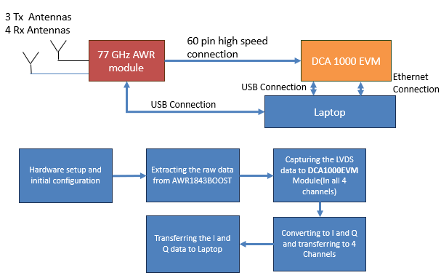

## Hardware Setup

The AWR1843 and DCA1000EVM moules are connected through the high density 60 pin cable. AWR1843 is connected to a COM port of a laptop (USB port) through an USB cable, which is used for configuring the Radar and controlling the data capturing events using the mmWaveStudio. DCA1000EVM module is also connected to another COM port (USB Port) of the laptop, which is used for configuring and invoking the card functions. the high-speed LAN port of the DCA1000EVM card has been connected to LAN port of the laptop through Gigabit LAN cable, which has been used for capturing the raw data generated by the RADAR module.

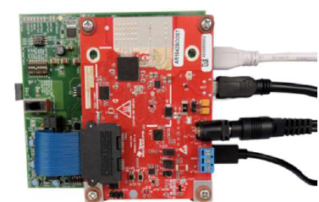

The system has been placed in a closed plastic box after fastening the modules. The box is cushioned and mounted on top of a car. The power supply cables are connected through a DC adapter, which converts 220 VAC to 5 VDC. The inverter has specification of converting 12 VDC to 220 VAC with 3 output sockets. The USB cables and the LAN cable has been connected to a laptop, which is used for entire sequence of operations.

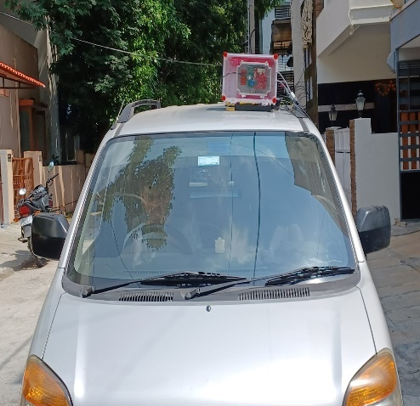

Once the power is turned on for the modules the RADAR setup is done through the mmWaveStudio as per the AWR specifications sections. RADAR module is configured through an available COM port. The serial communication is established through RS232 specifications with the baud rate of 921600.

The DCA1000EVM module can also be configured through mmWaveStudio. Configuration can be done through another COM port with TCP/IP communication between the systems. In the pre-configuration itself, file paths are configured which is used for storing the raw data once the data capture is completed.

Sequence of operations for data capture is as below:

### Connections configuration steps

1. Reset the board
2. Select the COM port for RADAR module
3. Set the baud rate as 921600
4. Connect to the COM Port.
5. Set the operating frequency (77 GHz) and device variant(xWR1843).
6. Specify the paths for firmware files (Available in the mmWaveStudio installation paths)
7. Set the SPI protocol for communication between RADAR module and DCA module.
8. RF power up.

### Data configuration steps

1. Set the data path as “LVDS”
2. Set the packets configurations to ADC_Only and suppress the packet 1
3. Set the CQ bits to 16 bit
4. Set the clock configuration to DDR Clock with data rate of 600 Mbps
5. Set the LVDS Lane configurations default values.

### Sensor configuration steps

1. Set the Start Frequency to 77 GHz, with frequency slope to 29.982 MHz/µs
2. Set the RF Gain target and RX gain to 30 dB
3. Enable all the transmission channels (3 channels - Tx1, Tx2 and Tx3) and Receiver channels (4 channels – Rx1, Rx2, Rx3 and Rx4)
4. Set the number of chirp loops in a frame to 128
5. Set the number of frames to 256
6. Set the file path for storing the raw data to any of the local computer path.
7. Keep all the other parameters to default values.

### LAN configuration steps

1. Enable the high-speed LAN for data transfer.
2. Wait till the version changes from 1.0.0 to the latest version (2.0.8)

## Data capturing and configuration verification

Following steps are followed for initiating the data capturing and configuration verification from the radar and DCM modules.

1. Prepare the connection configurations mentioned above. Intermediatory verifications are mentioned blow.
   1. Available COM ports should be displayed for the step b if the RADAR module is connected to USB port. If the baud rate is not configured properly for the USB ports, it can be configured through the Device Manger -> Universal Serial Bus Controllers. Selection of proper COM Port is essential for AWR module communication.
   2. Once the RS232 operations are configured, mmWaveStudio automatically recognizes the device variant. Operating frequency also gets defaulted to 77 GHz.
   3. After the steps from ‘f’, ‘g’, ‘h’, in the connection configurations, the connectivity status, device status, firmware versions etc are detected and the corresponding status are displayed.
2. Configure the LAN as mentioned in the ‘LAN configuration steps’. LAN firmware version should be updated from 1.0.0 to the latest version. This ensures the communication between DCA and Laptop for data transfer.
3. Perform the ‘Data configuration steps’ as mentioned above. Data configuration is just setting the appropriate parameters and this happens through the communication channels which are already setup in previous steps.
4. Perform the “Sensor configurations” by following the steps mentioned above. Once the configurations are completed, “DCA 1000 ARM” should be enabled and start the data capturing through the Radar by starting the “Trigger Frame” event. The green light in the front of the Radar module should be blinking as long as data capturing is in progress.

# Software

Complete source code of the project both in MATLAB and Python. Code can be downloaded from the below public repositories

Python Code:

<https://github.com/Sampreeth-Rayas/>[mmWaveRadar](https://github.com/Sampreeth-Rayas/mmWaveRadar)

MATLAB Code

<https://github.com/Sampreeth-Rayas/mmWaveRadaMATLAB>

## Data Structure

Raw data is having a single array of int16 bits containing all the 4 channel Low Voltage Differential Signal (LVDS) data of continuous chirp cycles. The structure of one frame data is as below:

* Ch -> Channel Number, Cn -> Chirp Number, lvds -> Low Voltage Differential Signal data

** All the data are of int16 format.

|  |  |  |  |  |
| --- | --- | --- | --- | --- |
| Ch1, Cn1,lvds1 | Ch1,Cn1,lvds2 | …… | Ch1,Cn1,lvds255 | Ch1,Cn1,lvds256 |
| Ch2, Cn1,lvds1 | Ch2,Cn1,lvds2 | …… | Ch2,Cn1,lvds255 | Ch2,Cn1,lvds256 |
| Ch3, Cn1,lvds1 | Ch3,Cn1,lvds2 | …… | Ch3,Cn1,lvds255 | Ch3,Cn1,lvds256 |
| Ch4, Cn1,lvds1 | Ch4,Cn1,lvds2 | …… | Ch4,Cn1,lvds255 | Ch4,Cn1,lvds256 |
| Ch1, Cn2,lvds1 | Ch1,Cn2,lvds2 | …… | Ch1,Cn2,lvds255 | Ch1,Cn2,lvds256 |
| Ch2, Cn2,lvds1 | Ch2,Cn2,lvds2 | …… | Ch2,Cn2,lvds255 | Ch2,Cn2,lvds256 |
| Ch3, Cn2,lvds1 | Ch3,Cn2,lvds2 | …… | Ch3,Cn2,lvds255 | Ch3,Cn2,lvds256 |
| Ch4, Cn2,lvds1 | Ch4,Cn2,lvds2 | …… | Ch4,Cn2,lvds255 | Ch4,Cn2,lvds256 |
| Ch1, Cn3,lvds1 | Ch1,Cn3,lvds2 | …… | Ch1,Cn3,lvds255 | Ch1,Cn3,lvds256 |
| …  …  … | …  …  … | ……  ……  …… | …  …  … | …  …  … |
| Ch1, Cn256,lvds1 | Ch1,Cn256,lvds2 | …… | Ch1,Cn256,lvds255 | Ch1,Cn256,lvds256 |
| Ch2, Cn256,lvds1 | Ch2,Cn256,lvds2 | …… | Ch2,Cn256,lvds255 | Ch2,Cn256,lvds256 |
| Ch3, Cn256,lvds1 | Ch3,Cn256,lvds2 | …… | Ch3,Cn256,lvds255 | Ch3,Cn256,lvds256 |
| Ch4, Cn256,lvds1 | Ch4,Cn256,lvds2 | …… | Ch4,Cn256,lvds255 | Ch4,Cn256,lvds256 |

LVDS data contains In phase and quadrature signals in alternate numbers. I and Q data can be derived from the array of LVDS data as below:

|  |  |  |  |  |  |  |  |  |
| --- | --- | --- | --- | --- | --- | --- | --- | --- |
| lvds1 | lvds2 | lvds3 | lvds4 | lvds5 | lvds6 | lvds7 | lvds8 | …….. |

….

I4 + jQ4

I3 + jQ3

I1 + jQ1

I2 + jQ2

The data has been re-arranged for one frame as below:

|  |  |  |  |  |
| --- | --- | --- | --- | --- |
| Ch1, Cn1,IQ1 | Ch1,Cn1,IQ2 | …… | Ch1,Cn1,IQ127 | Ch1,Cn1,IQ128 |
| Ch2, Cn1,IQ1 | Ch2,Cn1,IQ2 | …… | Ch2,Cn1,IQ127 | Ch2,Cn1,IQ128 |
| Ch3, Cn1,IQ1 | Ch3,Cn1,IQ2 | …… | Ch3,Cn1,IQ127 | Ch3,Cn1,IQ128 |
| Ch4, Cn1,IQ1 | Ch4,Cn1,IQ2 | …… | Ch4,Cn1,IQ127 | Ch4,Cn1,IQ128 |
| Ch1, Cn2,IQ1 | Ch1,Cn2,IQ2 | …… | Ch1,Cn2,IQ127 | Ch1,Cn2,IQ128 |
| Ch2, Cn2,IQ1 | Ch2,Cn2,IQ2 | …… | Ch2,Cn2,IQ127 | Ch2,Cn2,IQ128 |
| Ch3, Cn2,IQ1 | Ch3,Cn2,IQ2 | …… | Ch3,Cn2,IQ127 | Ch3,Cn2,IQ128 |
| Ch4, Cn2,IQ1 | Ch4,Cn2,IQ2 | …… | Ch4,Cn2,IQ127 | Ch4,Cn2,IQ128 |
| Ch1, Cn3,IQ1 | Ch1,Cn3,IQ2 | …… | Ch1,Cn3,IQ127 | Ch1,Cn3,IQ128 |
| …  …  … | …  …  … | ……  ……  …… | …  …  … | …  …  … |
| Ch1, Cn256,IQ1 | Ch1,Cn256,IQ2 | …… | Ch1,Cn256,IQ127 | Ch1,Cn256,IQ128 |
| Ch2, Cn256,IQ1 | Ch2,Cn256,IQ2 | …… | Ch2,Cn256,IQ127 | Ch2,Cn256,IQ128 |
| Ch3, Cn256,IQ1 | Ch3,Cn256,IQ2 | …… | Ch3,Cn256,IQ127 | Ch3,Cn256,IQ128 |
| Ch4, Cn256,IQ1 | Ch4,Cn256,IQ2 | …… | Ch4,Cn256,IQ127 | Ch4,Cn256,IQ128 |

Depending on the number of frames configured, say ‘n’ frames data has been arranged as below.

|  |  |  |  |
| --- | --- | --- | --- |
| Frame1  Data | Frame2  Data | ………………….. | Frame ‘n’  Data |

## Pre-Processing

This step is to populate the basic data structure required for processing steps. End objective of this step is to populating the I and Q data, segregating chirp data for each channel and restructuring to frames.

1. Calculating maximum number of frames from the file size of the raw LVDS data through the system class.

Note:

‘2’ in the denominator specifies I and Q data requires two int16 numbers of LVDS data.

1. Reading the raw LVDS data from the file
2. Initializing the data structure depending on maximum number of frames.
3. Populating I and Q data. I and Q data is a complex-valued orthogonal components of radar data from each pulse

z(t)=I(t)+jQ(t)

Complex numbers are formed as mentioned in the data structure section.

1. Populating the chirp data for each of the channels.
2. Organizing the chirps and creation of frames. Each frames are of the dimension 128x256. Each data element in the frame is a complex number

## Processing

This step involves below steps:

1. Reduction of gaussian noise.
2. Applying the Fast Fourier Transforms
3. Populating absolute data values
4. Data scaling
5. Data processing
6. Graph plotting

### Reduction of gaussian noise

For reducing the gaussian noise, all the 4 channel data values are summed up. With this, signal data gets added up and noise gets cancelled out.

### Applying the Fast Fourier transforms

Two methods are tried out in this project.

1. Applying One-dimension FFT for each of the chirps having absolute value of I and Q data. FFT has been applied across the bins and data has been plotted. This method gives only the range of moving object.
2. Applying Two-dimension FFT across the bins. FFT has been applied on both the axis for the entire frame. Applying FFT across chirps or slow-time axis results in resolving Doppler frequencies and derivation of speed.

Populating absolute data values

Absolute values of the I and Q data is derived after applying the FFT (s)

### Data scaling

Once the FFT is applied the data planes are added up exponentially. To derive the doppler domain values, logarithmic derivatives are applied to the FFT values.

If one-dimension FFT is applied, the doppler values are derived from the below equation.

f(t)

### Data processing

This step performs processing the data, reducing the noise, filtering of data to separate signal and the noise components, removing the aliasing.

Following parameters are used in the equations:

* Sampling Rate (): Used to calculate the range resolution.
* Chirp Slope (S): The rate of change of frequency in the radar chirp, which helps convert frequency bins into range bins.
* Chirp Interval (): Time duration of a chirp, used for calculating Doppler resolution.

### Range and Speed Calculation

The range is determined by measuring the time delay of a received signal. The Range FFT provides the range information, and the formula for range is derived as follows:

Equation

The range for each FFT bin k can be calculated as:

where,

* c is the speed of light
* k is the bin index in the Range FFT (from 0 to N/2, if one-dimension FFT is used)
* S is the chirp slope in Hz/s (rate of change of frequency in the transmitted chirp)
* N is the number of samples in each chirp (i.e., the FFT size in the range dimension).

### Range Resolution

The range resolution (smallest distinguishable distance between two objects) is given by:

This resolution depends on the sampling rate ​, chirp slope S, and the number of samples N.

### Doppler Resolution

The Doppler resolution (smallest distinguishable velocity difference between two objects) is given by:

### Maximum Unambiguous Velocity

The maximum unambiguous velocity that can be measured as per the below equation:

## Graph plotting

Before plotting the graphs, aliasing should be reduced for 2-Dimension FFT graphs.

### Doppler Aliasing

Aliasing in the Doppler domain can be reduced by using an additional filtering process. To plot the graph to reduce the aliasing, following methods are used:

* Zero-padding in the slow-time domain (Doppler FFT) can reduce spectral leakage.
* Thresholding in the Doppler FFT result can help mask or attenuate aliased signals.

x-axis, y-axis and z-axis are chosen depending on the plot of the graph.

Following graphs are drawn and analyzed for various data sets

### Raw data map

This graph shows plotting of absolute values of raw data captured through the RADAR module.

### One-dimension FFT map

One-dimension FFT is applied on the raw data and logarithmic scaling is done on the data in this map. Data plotted is for one of the frames.

### Two-dimension FFT map with filtering

Two-dimension FFT is applied on the raw data and logarithmic scaling is done on the data in this map. Filtering is done to remove the static objects and also maximum threshold is set for high pass filtering. Data plotted is for one of the frames.

### Range – Doppler map

Range doppler map is populated for each of the frames separately. Post reduction of gaussian noise, absolute values of two dimensional FFT data is filtered through a high pass filter and passed to this map frame by frame. The moving objects and the range can be seen in this map. However, X and Y axes do not indicate the correct values since the deriving and mapping the axes is not done.

### Range-Speed map

The equations for calculating Range and Speed are given in the previous section. The data used for drawing the range-doppler map is further processed for deriving Range-Speed map. Following steps needs to be followed before drawing the range-speed map.

* Reduce the doppler aliasing as mentioned above.
* Apply the FFT Shift so that the incoming and outgoing objects can be classified easily.
* Post scaling of the data, apply the high pass filter to extract the signal part.
* Derive the Doppler resolution and maximum unambiguous velocity from the equations mentioned in the previous section.
* Derive the speed and data values for each of the elements of the matrix.
* Remove the static objects from the plot. The static objects are determined where speed is zero.
* Reduce the clustering of points specifically near to the beginning of moving objects. Also use the doppler resolution and maximum velocity to determine the x and y axis maximum values. Distance on the x-axis ranges from -Vmax to +Vmax.
* Form the speed buckets to represent moving objects in different colours based on the speed.

Range Vs Speed map gives speed of the moving object at a certain distance from the radar. To simplify the graph and analyzing the graph easier, radar is mounted on the car which is not moving. This make sure that the range is equal to the distance from the radar.

# Results

### Raw data map

The plot of Raw data map of I and Q data is presented below. This graph does not indicate anything and just looks like some random values. Only processed data leads to the valuable information.is

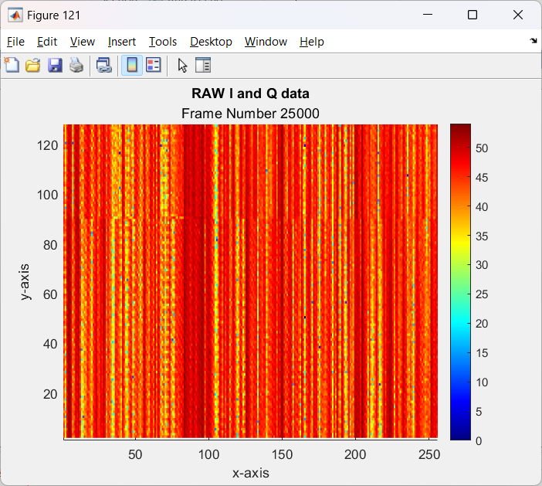

### One-dimension FFT map

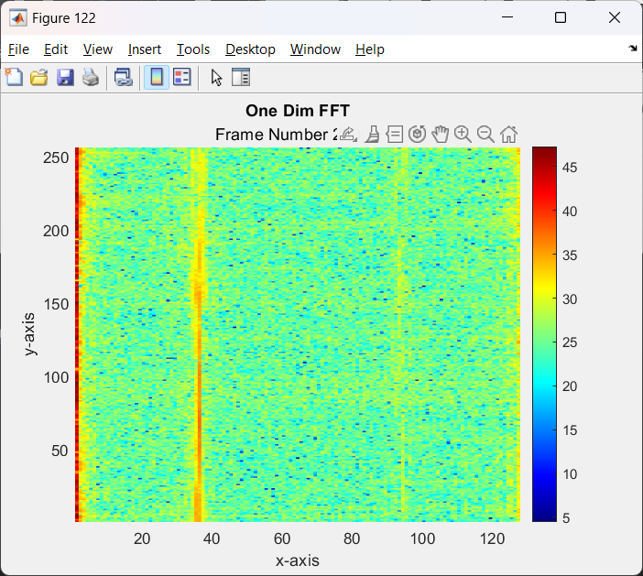

One-dimension FFT map for one frame is presented above. We can observe that objects that are moving forms a line parallel to y-axis. Also, we can observe that near the point x=0, radar has detected many points. The points plotted near to x=0 has zero doppler, that means all these points are corresponds to static objects. We can safely ignore these points in the further map.

### Two-dimension FFT with filtering

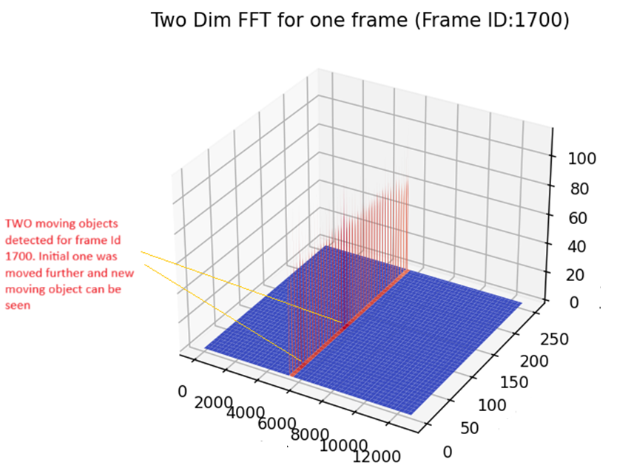

This map indicates that two moving objects are detected where density of the lines are more compare to other places. However, x-axis and y-axis are not scaled and do not represent the actual values.

### Two-dimension FFT for a frame

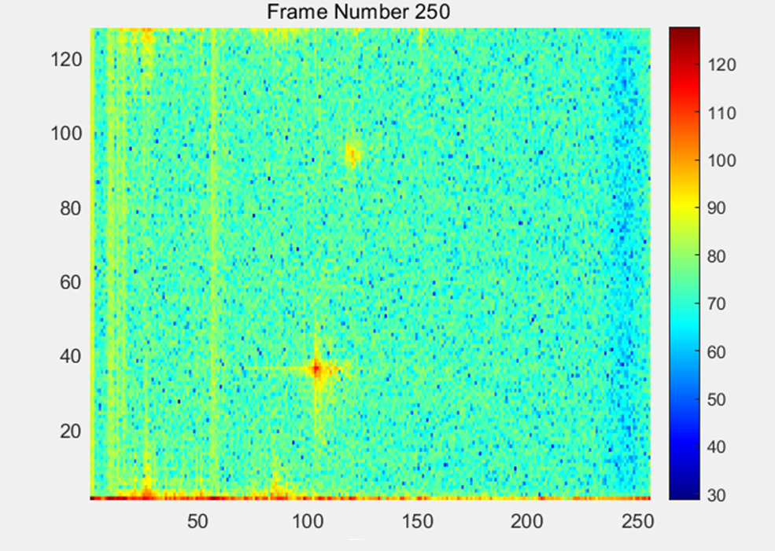

Two-dimension FFT map where FFT has been applied to both In-phase and Quadrature data for one frame is represented in the above graph. We can clearly see that two moving objects are detected in this map. Since the transpose of the data matrix is taken here, near to the x-axis we can observe many static objects.

The x-axis and the y-axis are not up-to the scale since Range and speed are not derived yet. Also, this indicates that FFT shift needs to be applied to separate the incoming and outgoing objects.

### Range – Doppler map

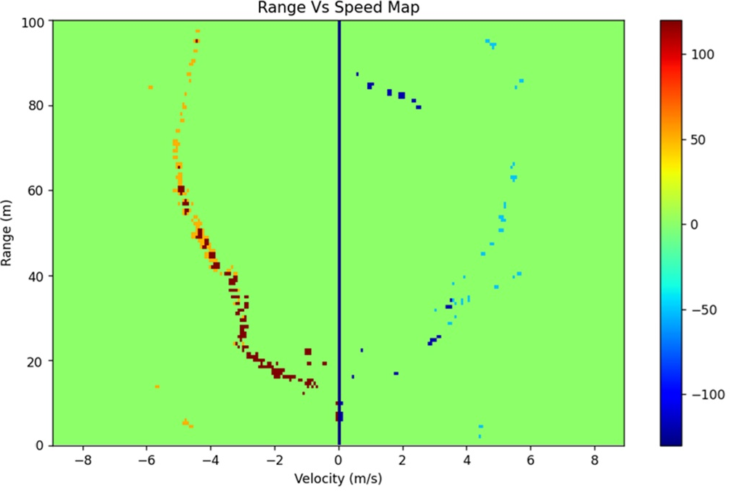

Range doppler map indicates the speed at which the vehicles are moving at a given distance. Radar can capture maximum of 100-meter objects, which is represented on y-axis. X-axis indicates the speed at which the vehicles are moving. In the test condition, radar is static and hence the range is equal to the distance from radar. Negative speed indicates that the object is moving away from radar. In the above map, we can observe that more denser points on the left side of the graph, which indicates that the broader vehicle is moving (Car). On the right side, a cycle is moving and the points are less dense. Also, we can observe that an animal is moving at around 80-meter distance which is moving towards the radar.

# Clustering

When plotting the time-distance matrix, it is observed that the data about the objects are scattered across multiple columns, as shown below:

Figure: First and second column data

Thus, all columns are stored in a single matrix and reshaped for plotting purposes. Once this is done, the data needs to be clustered to identify the object paths. Several algorithms exist for this, such as:

K-Means: an unsupervised algorithm where K (predefined) centroid points are randomly chosen, and iteratively updated based on the distance of other points from them.

DBSCAN: groups highly dense sets of points together and marks points in low-density regions as noise or outliers. It uses ε (neighbourhood radius for a point) and Minpts (Minimum number of points required in a neighbourhood to form a cluster) as parameters.

BIRCH: uses a tree structure to incrementally and dynamically cluster large datasets. It first builds the tree, then refines clusters through multiple iterations.

In the interest of speed and simplicity, K-Means clustering has been chosen. It has also given good results for 2-3 objects over multiple datasets.

The number of clusters can be automatically chosen by using the elbow method. This involves iterating through a set of K values. Within each iteration, the sum of squared distances (aka sum of squared error, SSE) between each point and its assigned cluster centroid, is calculated. As K increases, the SSE will decrease since more clusters better fit the data. The point with the highest slope difference in the K vs SSE graph is the elbow point, which indicates the optimal K value.

Figure: Optimal no. of clusters determined using Elbow Method

Figure: Data from all columns clustered using K-Means

It is seen that there are some gaps in the supposed object paths. These are areas where the radar was not able to detect the object likely due to the small size of an object (eg. a bike) or its movement outside the radar’s FOV.

In order to track the object(s) even when they aren’t being detected, values are interpolated using the fillmissing command with fill type MAKIMA (Modified Akima piecewise cubic Hermite interpolation). It is an advanced interpolation method used to construct smooth curves through a set of data points. It differs from AKIMA by preserving the monotonicity of the data while ensuring that the interpolated curve does not oscillate excessively. Other interpolation methods such as linear, pchip and cubic were either too simple or oscillated wildly.

Post interpolation, a curve is drawn through each of the clusters to accurately predict the objects’ positions. This was done using the smoothdata function with the moving mean method and a window of 15 points. Additionally, some truncation of curves may be performed at the first and last datapoints as the prediction curve becomes inaccurate at the mentioned points.

Figure: Tracked positions of two objects

# CONCLUSION AND ANALYSIS

## Summary

In this paper, a mountable and efficient radar setup has been implemented on a vehicle (car) and various algorithms for detection and tracking are performed.

mmWave radar has emerged as a transformative technology for tracking and detecting moving objects. Algorithms like 1D-FFT, 2D-FFT, and CA-CFAR play pivotal roles in enabling precise range, velocity, and angle measurements.

The mathematical modelling and feature extraction techniques explored in this research provide a strong foundation.

While working on this project, several ideas were brainstormed to various possibilities of implementing algorithms related to our work, but owing to the limited training data, the Kalman filter and CNN could not be implemented as planned.

## Interpretations

From the above experiment, we can infer that an effective detection and tracking algorithm provides a result-oriented solution for such practical purposes. The results obtained in this project are noteworthy and provides an estimate of the overall efficiency of the setup.

# Future Work

While challenges such as interference and computational demands persist, advancements in AI and multi-sensor fusion promise to elevate radar's capabilities further. Future research should focus on optimizing hardware and algorithms to unlock the full potential of mmWave radar across diverse applications.

Additionally, the integration of machine learning methods such as SVMs and CNNs enables automated classification, making mmWave radar systems smarter and more adaptive.

The field of micro-Doppler analysis for mmWave radar is rich with potential for further exploration and innovation. Future work in this domain can address current limitations, explore new applications, and integrate advanced technologies to enhance performance and scalability.

**Integration of AI and Machine Learning**

One of the most promising directions for future work is the integration of artificial intelligence (AI) and machine learning (ML) with micro-Doppler analysis. AI models, especially deep learning frameworks, can be trained to identify subtle patterns in micro-Doppler signatures that are difficult for traditional algorithms to discern. Techniques such as convolutional neural networks (CNNs) and recurrent neural networks (RNNs) can enhance classification accuracy for complex motions, such as differentiating between human activities, vehicle types, or drone propeller patterns. Furthermore, unsupervised and semi-supervised learning can be employed to handle large datasets with minimal manual labeling.

**Real-Time Processing and Hardware Optimization**

Real-time processing remains a significant challenge in micro-Doppler analysis, particularly for applications requiring immediate decision-making, such as autonomous driving or defense systems. Future work could focus on developing optimized signal processing pipelines and implementing them on high-performance hardware platforms like field-programmable gate arrays (FPGAs) or graphics processing units (GPUs). The use of edge computing can also reduce latency, enabling faster data analysis directly on the radar system.

## Multi-Sensor Fusion

Combining micro-Doppler analysis with other sensor modalities, such as LiDAR, cameras, and ultrasonic sensors, presents an exciting avenue for future development. Multi-sensor fusion can provide a more comprehensive understanding of the environment, improving the accuracy and robustness of object detection and classification. For instance, integrating radar’s micro-Doppler signatures with visual data from cameras can enhance activity recognition in cluttered or low-visibility conditions.

**Expanding Application Areas**

Micro-Doppler analysis has applications beyond traditional domains like automotive and defence. Future work can expand its usage in emerging fields such as:

* **Healthcare**: Monitoring patient movement, detecting falls, or assessing gait abnormalities in rehabilitation and eldercare settings.
* **Smart Homes and Buildings**: Enabling gesture-based control systems and occupancy detection for energy-efficient automation.
* **Agriculture**: Identifying animal activities or monitoring machinery in large-scale farming operations.

## Addressing Noise and Clutter

Environmental noise and clutter remain persistent challenges in micro-Doppler analysis. Developing advanced denoising techniques and adaptive algorithms can significantly improve radar performance. Methods such as robust principal component analysis (RPCA) and adaptive filtering can help separate micro-Doppler signatures from background interference in complex scenarios.

## Higher Frequency Bands and Ultra-Wideband Radar

Exploring the use of higher frequency bands and ultra-wideband (UWB) radar systems can improve resolution and sensitivity in micro-Doppler analysis. This advancement would allow for finer discrimination of small or distant objects, broadening the scope of radar applications in both civilian and military contexts.

## Simulations and Dataset Development

Building comprehensive and publicly available datasets for training and validating micro-Doppler models is a critical future task. Simulations using realistic motion models and environmental scenarios can supplement real-world data collection, providing researchers with diverse datasets for algorithm testing.

The integration of the Extended Kalman Filter (EKF) as a part of future work for micro-Doppler analysis in mmWave radar systems holds significant potential to enhance motion tracking, state estimation, and object classification. The EKF is a powerful tool for processing nonlinear systems, making it an ideal candidate for refining radar signal processing and interpretation.

## Role of EKF in Micro-Doppler Analysis

In mmWave radar systems, the micro-Doppler effect captures the nuanced motion dynamics of objects, such as limb movements, rotating blades, or vibrating components. These motions introduce nonlinearities in the Doppler signature, which can be challenging to process using traditional linear filtering techniques. The EKF, an extension of the Kalman Filter designed to handle nonlinearities, can predict and update the state of such dynamic systems effectively.

By leveraging EKF, future implementations can:

* Smooth noisy micro-Doppler signals.
* Estimate dynamic states such as position, velocity, and acceleration of objects.
* Improve the accuracy of motion reconstruction for objects with complex behaviors.

## Enhancing Tracking and State Estimation

One of the critical challenges in micro-Doppler analysis is accurately tracking fast-moving objects or objects performing intricate movements. The EKF excels in tracking by combining sensor data with a predictive model. For instance:

* In an automotive context, EKF can track multiple vehicles or pedestrians with high precision, even in cluttered or noisy environments.
* In human activity recognition, EKF can estimate joint angles or limb velocities, enabling detailed motion analysis for applications like physical therapy or sports science.

Future work could focus on implementing EKF to simultaneously estimate linear motion (e.g., vehicle trajectory) and micro-Doppler parameters (e.g., rotational speeds of wheels or limbs).

## Multi-Sensor Fusion Using EKF

The EKF is particularly well-suited for sensor fusion, which combines data from multiple sensors to improve system robustness and accuracy. Future work could integrate mmWave radar data with inputs from LiDAR, cameras, or IMUs (Inertial Measurement Units) to create a comprehensive situational awareness system. For example:

* In autonomous vehicles, EKF could fuse radar micro-Doppler data with visual information from cameras to accurately identify and classify objects.
* In robotics, EKF could integrate radar data with motion sensors to improve real-time navigation and gesture recognition.

## Application in Nonlinear System Modelling

Micro-Doppler signatures often exhibit nonlinear dynamics due to oscillatory or rotational movements. EKF can model these nonlinear behaviors effectively by linearizing the system around the current state estimate at each time step. This capability is critical for applications like:

* Predicting human joint movements in healthcare monitoring.
* Modelling dynamic scenes in crowded environments for smart city surveillance.

## Challenges and Future Directions

While EKF offers many advantages, future work must address its computational complexity, especially for real-time systems. Optimized implementations on hardware platforms such as GPUs or FPGAs could mitigate this issue. Additionally, tuning the EKF parameters, such as process noise and measurement noise covariance matrices, will be critical for achieving robust and consistent performance across diverse scenarios in a practical world.  
  
Despite these advancements, challenges such as environmental noise, clutter, and real-time processing constraints persist. Future research must focus on improving hardware capabilities, leveraging AI-driven analytics, and integrating sensor fusion to overcome these limitations. mmWave radar, with its enhanced sensitivity and resolution, continues to be a promising tool for advancing technology in diverse fields, underscoring its potential for widespread applications in a rapidly evolving technological landscape in a real world.

# REFERENCES

[1] Venkatesha.K, A Vengadarajan, and Upasna Singh, “Detection mechanism for vehicle collision avoidance using mmWave Radar”, in *Proc. 2023 IEEE Int. Conf. Electronics, Computing and Communication Technologies (CONECCT)*, 2023, pp. 1-5

[2] Jie Ren, Lingling Zhang, Jiaao Liu, “Research and Implementation of 77GHz Automotive Radar Target Detection Technology”, 2023 6th International Conference on Information Communication and Signal Processing

[3] Pape Sanoussy Diao, Thierry Alves and Benoit Poussot , ESYCOM Lab, Sylvain Azarian, “A Review of Radar Detection Fundamentals”, IEEE A&E SYSTEMS MAGAZINE SEPTEMBER 2024, DOI. No. 10.1109/MAES.2022.3177395

[4] Pitre, Eric, Vincent Roberge, Joey Bray, and Mostafa Hefnawi. "MIMO Radar Hardware Acceleration with Enhanced Resolution." In *ITM Web of Conferences*, vol. 48. EDP Sciences, 2022.

[5] Vandana G S, Bethi Pardhasaradhi and Pathipati Srihari, “Intruder Detection and Tracking using 77GHz FMCW Radar and Camera Data”, 2022 IEEE International Conference on Electronics, Computing and Communication Technologies (CONECCT) ,DOI: 10.1109/CONECCT55679.2022.9865707

[6] Sathishkumar Rangasamy, Wang Ling Goh, Zhong Zhigang, “A Study on 77 GHz Automotive Radar for Radar-Camera Fusion Module”, 2021 3rd International Conference on Electrical Engineering and Control Technologies (CEECT, DOI: 10.1109/CEECT53198.2021.9672644

[7] Venkatesha K, A Venkadarajan and Upasana Singh, “Detection and simple tracking Method for ADAS using a mmWave Radar”, IEEE 4th Annual Flagship India Council International Subsections Conference (INDISCON), IEEE xPlore, IEEE 2023, DOI: 10.1109/INDISCON58499.2023.10270092

[8] M. B. Alabd, L. G. de Oliveira, B. Nuss, Y. Li, A. Diewald, and T. Zwick, "Modified Pulse Position Modulation for Joint Radar Communication Based on Chirp Sequence," *IEEE Microwave and Wireless Components Letters*, vol. 32, no. 10, pp. 1247, Oct. 2022

[9] W. Zhang, N. Li, H. Zha, Q. Wang, J. Zhang, X. Li, J. Yu, and E. Kasper, "A Software-Adaptive 77GHz Radar Sensor for Traffic Applications," in Proc. IEEE International Wireless Symposium (IWS), 2021, pp. 1-5.

[10] E. Pitre, V. Roberge, J. Bray, and M. Hefnawi, "MIMO radar hardware acceleration with enhanced resolution," *ITM Web of Conferences*, vol. 48, Art. no. 01013, pp. 1–6, 2022

[11] L. Chen, S. Zhou, and W. Wang, "MmWave beam tracking with spatial information based on extended Kalman filter," *IEEE Wireless Communications Letters*, vol. 12, no. 4, pp. 123-127, Apr. 2023